What is a File?
A file can be defined as a data structure which stores the sequence of records. Files are stored in a file system, which may exist on a disk or in the main memory. Files can be simple (plain text) or complex (specially-formatted).
The collection of files is known as Directory. The collection of directories at the different levels, is known as File System.
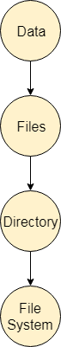

Attributes of the File
1.Name
Every file carries a name by which the file is recognized in the file system. One directory cannot have two files with the same name.
2.Identifier
Along with the name, Each File has its own extension which identifies the type of the file. For example, a text file has the extension .txt, A video file can have the extension .mp4.
3.Type
In a File System, the Files are classified in different types such as video files, audio files, text files, executable files, etc.
4.Location
In the File System, there are several locations on which, the files can be stored. Each file carries its location as its attribute.
5.Size
The Size of the File is one of its most important attributes. By size of the file, we mean the number of bytes acquired by the file in the memory.
6.Protection
The admin of the computer may want the different protections for the different files. Therefore, each file carries its own set of permissions to the different group of Users.
7.Time and Date
Every file carries a time stamp which contains the time and date on which the file is last modified.

Operations on the File
A file is a collection of logically related data that is recorded on the secondary storage in the form of sequence of operations. The content of the files is defined by its creator who is creating the file. The various operations which can be implemented on a file such as read, write, open and close etc. are called file operations. These operations are performed by the user by using the commands provided by the operating system. Some common operations are as follows:
TYPES OF FILE OPERATIONS:
- Create operation:
This operation is used to create a file in the file system. It is the most widely used operation performed on the file system. To create a new file of a particular type the associated application program calls the file system. This file system allocates space to the file. As the file system knows the format of directory structure, so entry of this new file is made into the appropriate directory.
2. Open operation: of Java
This operation is the common operation performed on the file. Once the file is created, it must be opened before performing the file processing operations. When the user wants to open a file, it provides a file name to open the particular file in the file system. It tells the operating system to invoke the open system call and passes the file name to the file system.
3. Write operation:
This operation is used to write the information into a file. A system call write is issued that specifies the name of the file and the length of the data has to be written to the file. Whenever the file length is increased by specified value and the file pointer is repositioned after the last byte written.
4. Read operation:
This operation reads the contents from a file. A Read pointer is maintained by the OS, pointing to the position up to which the data has been read.
5. Re-position or Seek operation:
The seek system call re-positions the file pointers from the current position to a specific place in the file i.e., forward or backward depending upon the user's requirement. This operation is generally performed with those file management systems that support direct access files.
6. Delete operation:
Deleting the file will not only delete all the data stored inside the file it is also used so that disk space occupied by it is freed. In order to delete the specified file, the directory is searched. When the directory entry is located, all the associated file space and the directory entry is released.
7. Truncate operation:
Truncating is simply deleting the file except deleting attributes. The file is not completely deleted although the information stored inside the file gets replaced.
8. Close operation:
When the processing of the file is complete, it should be closed so that all the changes made permanent and all the resources occupied should be released. On closing it deallocates all the internal descriptors that were created when the file was opened.
9. Append operation:
This operation adds data to the end of the file.
10. Rename operation:
This operation is used to rename the existing file.

File Access Methods
Let's look at various ways to access files stored in secondary memory.

Sequential Access
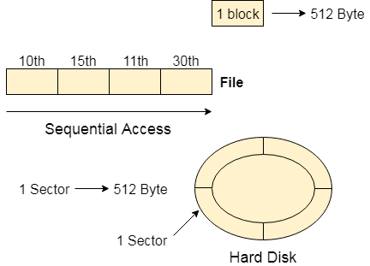
Most of the operating systems access the file sequentially. In other words, we can say that most of the files need to be accessed sequentially by the operating system.
In sequential access, the OS read the file word by word. A pointer is maintained which initially points to the base address of the file. If the user wants to read first word of the file then the pointer provides that word to the user and increases its value by 1 word. This process continues till the end of the file.
Modern word systems do provide the concept of direct access and indexed access but the most used method is sequential access due to the fact that most of the files such as text files, audio files, video files, etc need to be sequentially accessed. Concepts in Java

Direct Access
The Direct Access is mostly required in the case of database systems. In most of the cases, we need filtered information from the database. The sequential access can be very slow and inefficient in such cases.
Suppose every block of the storage stores 4 records and we know that the record we needed is stored in 10th block. In that case, the sequential access will not be implemented because it will traverse all the blocks in order to access the needed record.
Direct access will give the required result despite of the fact that the operating system has to perform some complex tasks such as determining the desired block number. However, that is generally implemented in database applications.
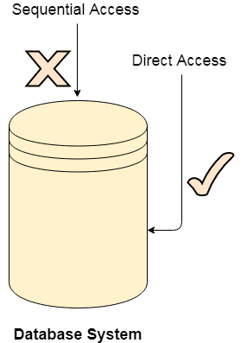

Indexed Access
If a file can be sorted on any of the filed then an index can be assigned to a group of certain records. However, A particular record can be accessed by its index. The index is nothing but the address of a record in the file.
In index accessing, searching in a large database became very quick and easy but we need to have some extra space in the memory to store the index value.

Directory Structure

What is a directory?
Directory can be defined as the listing of the related files on the disk. The directory may store some or the entire file attributes.
To get the benefit of different file systems on the different operating systems, A hard disk can be divided into the number of partitions of different sizes. The partitions are also called volumes or mini disks.
Each partition must have at least one directory in which, all the files of the partition can be listed. A directory entry is maintained for each file in the directory which stores all the information related to that file.
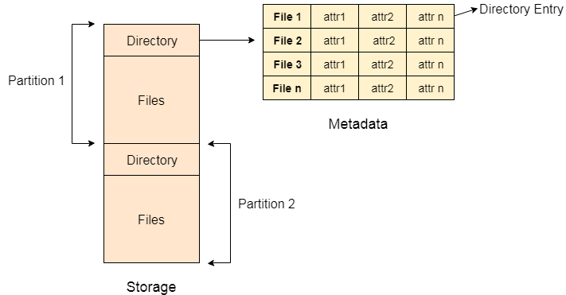
A directory can be viewed as a file which contains the Meta data of the bunch of files.History of Java
Every Directory supports a number of common operations on the file:
- File Creation
- Search for the file
- File deletion
- Renaming the file
- Traversing Files
- Listing of files

Single Level Directory
The simplest method is to have one big list of all the files on the disk. The entire system will contain only one directory which is supposed to mention all the files present in the file system. The directory contains one entry per each file present on the file system.
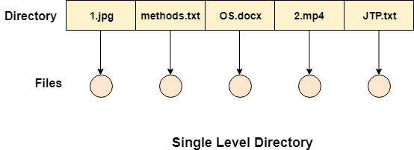
This type of directories can be used for a simple system.

Advantages
- Implementation is very simple.
- If the sizes of the files are very small then the searching becomes faster.
- File creation, searching, deletion is very simple since we have only one directory.

Disadvantages
- We cannot have two files with the same name.
- The directory may be very big therefore searching for a file may take so much time.
- Protection cannot be implemented for multiple users.
- There are no ways to group same kind of files.
- Choosing the unique name for every file is a bit complex and limits the number of files in the system because most of the Operating System limits the number of characters used to construct the file name.

Two Level Directory
In two level directory systems, we can create a separate directory for each user. There is one master directory which contains separate directories dedicated to each user. For each user, there is a different directory present at the second level, containing group of user's file. The system doesn't let a user to enter in the other user's directory without permission.
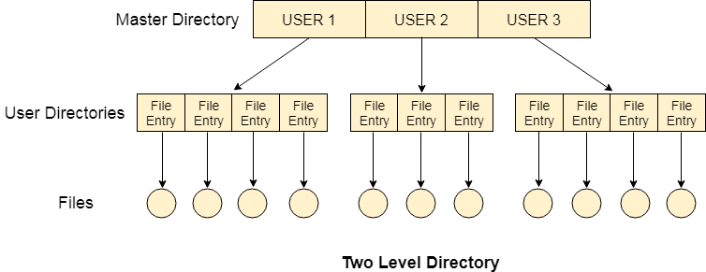

Characteristics of two level directory system
- Each files has a path name as /User-name/directory-name/
- Different users can have the same file name.
- Searching becomes more efficient as only one user's list needs to be traversed.
- The same kind of files cannot be grouped into a single directory for a particular user.
Every Operating System maintains a variable as PWD which contains the present directory name (present user name) so that the searching can be done appropriately.

